**AI Powered Image Transformation Tool**

***Undertaken By:***

**Muhammad Usman Saleem**

**CIIT/FA21-BSE-039/Vehari**

**Muhammad Fareed**

**CIIT/FA21-BSE-032/Vehari**

***Supervised By:***

**Dr Rab Nawaz Bashir**



**A PROPOSAL SUBMITTED AS A NEW IDEA FULFILLMENT OF THE REQUIREMENTS FOR THE DEGREE OF BACHELORS IN SOFTWARE ENGINEERING**

**DEPARTMENT OF COMPUTER SCIENCES**

**COMSATS UNIVESITY ISLAMABAD, VEHARI CAMPUS**

**VEHARI – PAKISTAN**

**SESSION 2021-2025**

# Table of Contents

Table of Contents ii

1 Introduction 1

1.1 Project Overview 1

1.2 Background and Motivation 1

2 Aim and Objectives of the Project 2

3 Proposed Solution 3

3.1 Functional Requirements 3

3.2 Non-Functional Requirements 3

3.3 Technology Stack 4

4 Project Plan 4

4.1 Gantt Chart (Timeline) 4

5 Conclusion 5

# Introduction

## Project Overview

This project aims to develop a cutting-edge web application that empowers users to transform their photos into well-known artistic styles through the power of AI-driven style transfer algorithms. By offering a platform where users can upload images and apply styles reminiscent of famous artists like Van Gogh, Picasso, and others, the application brings a unique combination of creativity and technology to life. Utilizing pre-trained AI models, the app allows users to effortlessly enhance their photos, providing them with a visually stunning, artistic output in real time. This interactive experience blends machine learning with the human desire for artistic expression, offering a tool that can be both fun and functional.

Beyond mere filters, the app provides a richer, more complex transformation experience by mimicking the distinctive strokes and color palettes of legendary artists. Users can seamlessly turn their everyday photos into creative masterpieces, a concept that can appeal not only to digital artists but also to casual users looking to experiment with artistic effects.

## Background and Motivation

In recent years, the demand for creative digital tools has skyrocketed, especially with the advent of AI and machine learning technologies that enable new forms of artistic expression. While several existing applications provide basic image manipulation features or photo filters, very few offer an in-depth transformation based on the aesthetics of famous artists. This gap presents a significant opportunity to create an app that brings together both complex AI algorithms and an intuitive user experience, making advanced art style transfer accessible to the general public.

As the boundary between technology and creativity continues to blur, AI has shown its potential in fields ranging from music composition to visual art. This project taps into that emerging trend, motivated by the need for tools that allow users to effortlessly create something unique and artistic with minimal technical knowledge. With this in mind, the development of this AI-based web app seeks to make advanced artistic tools more widely available, particularly in a time where personalization and creativity in digital spaces are highly sought after.

## Significance of Ai in Digital Art

The intersection of AI and art has been an exciting development in recent years. AI-powered tools are revolutionizing creativity by allowing even non-professional users to generate artwork in the styles of renowned artists. With the surge in digital art, this app will give users an accessible platform to explore AI-generated art transformations.

# Aim and Objectives of the Project

**Aim**

The primary aim of this project is to develop a web-based platform that utilizes AI algorithms for transferring artistic styles onto images uploaded by users. The application should provide a seamless interface for users to engage with AI-generated art, transforming their images into works of art in real-time.

**Objectives**

* **Develop a user-friendly platform:**

Ensure users can easily upload images and apply various artistic styles without technical complications.

* **Incorporate pre-trained AI models:**

Use existing machine learning models trained on large datasets to provide an array of artistic transformations.

* **Ensure real-time processing:**

Optimize the platform so that image processing occurs quickly, offering near real-time feedback to users.

* **Facilitate image downloads:**

Enable users to save their transformed images directly from the platform.

* **Scalability and Performance:**

Design the app to support concurrent users and offer high performance, scaling with user demands.

* **Dataset Sourcing and Training:**

Utilize the Kaggle dataset for further training of models to enhance the diversity and quality of the artistic styles available to users.

* **Accessibility:**

Ensure that the platform is easy to navigate for both casual users and those seeking more detailed artistic customizations.

# Proposed Solution

## Functional Requirements

* **User Interface:**

A responsive and intuitive design that allows users to upload their images and apply art styles effortlessly. Users should be able to see a preview of the stylized image before downloading.

* **Style Transfer:**

The core feature of the app, using TensorFlow-based AI models, will enable style transfer of images. These models will be pre-trained on a variety of famous art styles, and users will have the option to choose from different styles.

* **Image Download:**

After transforming the images, users will have the ability to download their stylized artwork in various formats (JPEG, PNG).

* **User Management:**

An optional user login feature will allow users to create accounts, save their image history, and manage their past transformations.

* **Real-Time Image Processing:**

Ensure that images are processed quickly, ideally in under 5 seconds, so that users experience minimal delay.

## Non-Functional Requirements

* **Performance:**

The application should be optimized to handle up to 100 users simultaneously, maintaining fast response times even under heavy traffic.

* **Usability:**

The user interface should be clean, clear, and simple to navigate, ensuring that even users with minimal technical knowledge can easily use the platform.

* **Security:**

The platform will use HTTPS to ensure secure uploads and downloads, protecting user data and image files.

* **Scalability:**

The application will be designed to handle growing demand, with provisions for adding new models or features in the future.

* **Reliability:**

The app should be available without major downtimes, ensuring a consistent user experience. Regular backups and monitoring should be implemented to prevent data loss or crashes.

## Technology Stack

* **Frontend:**

React.js will be used to create a dynamic and responsive user interface, offering smooth transitions and quick interactions.

* **Backend:**

Flask or Django will be used to handle the backend operations, manage user requests, and interface with the AI models.

* **AI Models:**

TensorFlow will be employed for implementing the style transfer models, leveraging pre-trained models for effective image transformation.

* **Image Processing:**

OpenCV will be integrated to handle the technical aspects of image manipulation and processing.

* **Database:**

PostgreSQL or MongoDB will store user data, including image history and login details.

* **Hosting:**

The web app will be deployed on AWS or Heroku for scalable and reliable hosting services.

# Project Plan

## Gantt Chart (Timeline)

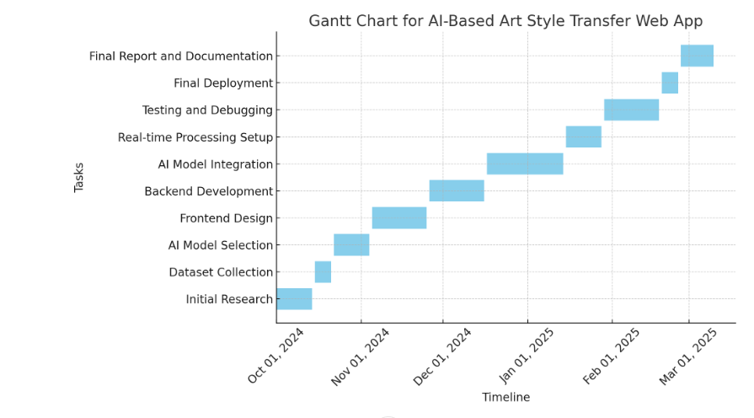

# Conclusion

The AI Powered Image Transformation Tool aims to bring the power of AI-driven artistic transformation into the hands of users, offering them a creative tool that combines technology and art. With a robust backend powered by advanced AI algorithms and a user-friendly frontend, the app offers a unique blend of efficiency and creativity. Whether for casual use or professional artistic experimentation, this web application has the potential to attract a wide audience, contributing to the growing trend of AI-enhanced creativity.